TDD using JUnit5

**Candidate Name:** Ayush Singh  
**Superset ID:** 6376485

1. JUnit_Basic Testing Exercises

Exercise 1: Setting Up JUnit

Scenario:

You need to set up JUnit in your Java project to start writing unit tests.

Steps:

1. Create a new Java project in your IDE (e.g., IntelliJ IDEA, Eclipse).

2. Add JUnit dependency to your project. If you are using Maven, add the following to your

pom.xml:

<dependency>

<groupId>junit</groupId>

<artifactId>junit</artifactId>

<version>4.13.2</version>

<scope>test</scope>

</dependency>

3.Create a new test class in your project.

HandsOn:

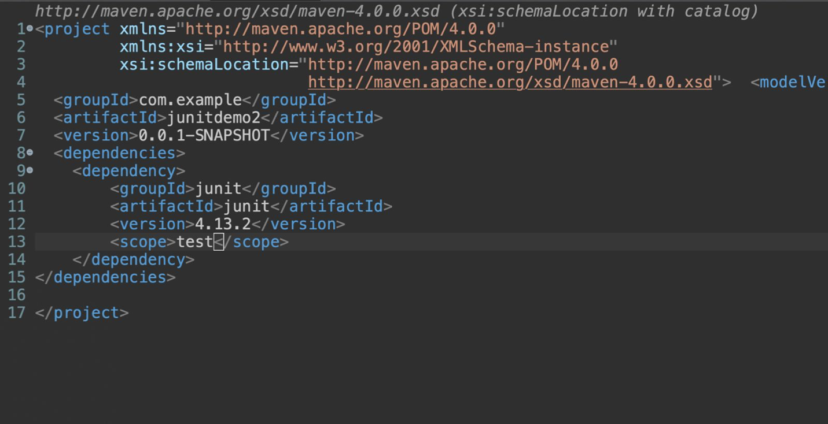

Exercise 3: Assertions in JUnit

Scenario:

You need to use different assertions in JUnit to validate your test results.

Steps:1. Write tests using various JUnit assertions.

Solution Code:

public class AssertionsTest {

@Test

public void testAssertions() {

// Assert equals

assertEquals(5, 2 + 3);

// Assert true

assertTrue(5 > 3);

// Assert false

assertFalse(5 < 3);

// Assert null

assertNull(null);

// Assert not null

assertNotNull(new Object());

}

}

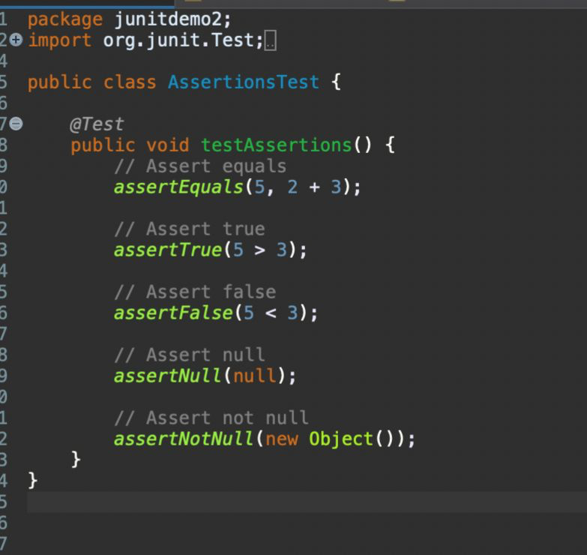HandsOn:

OUTPUT:

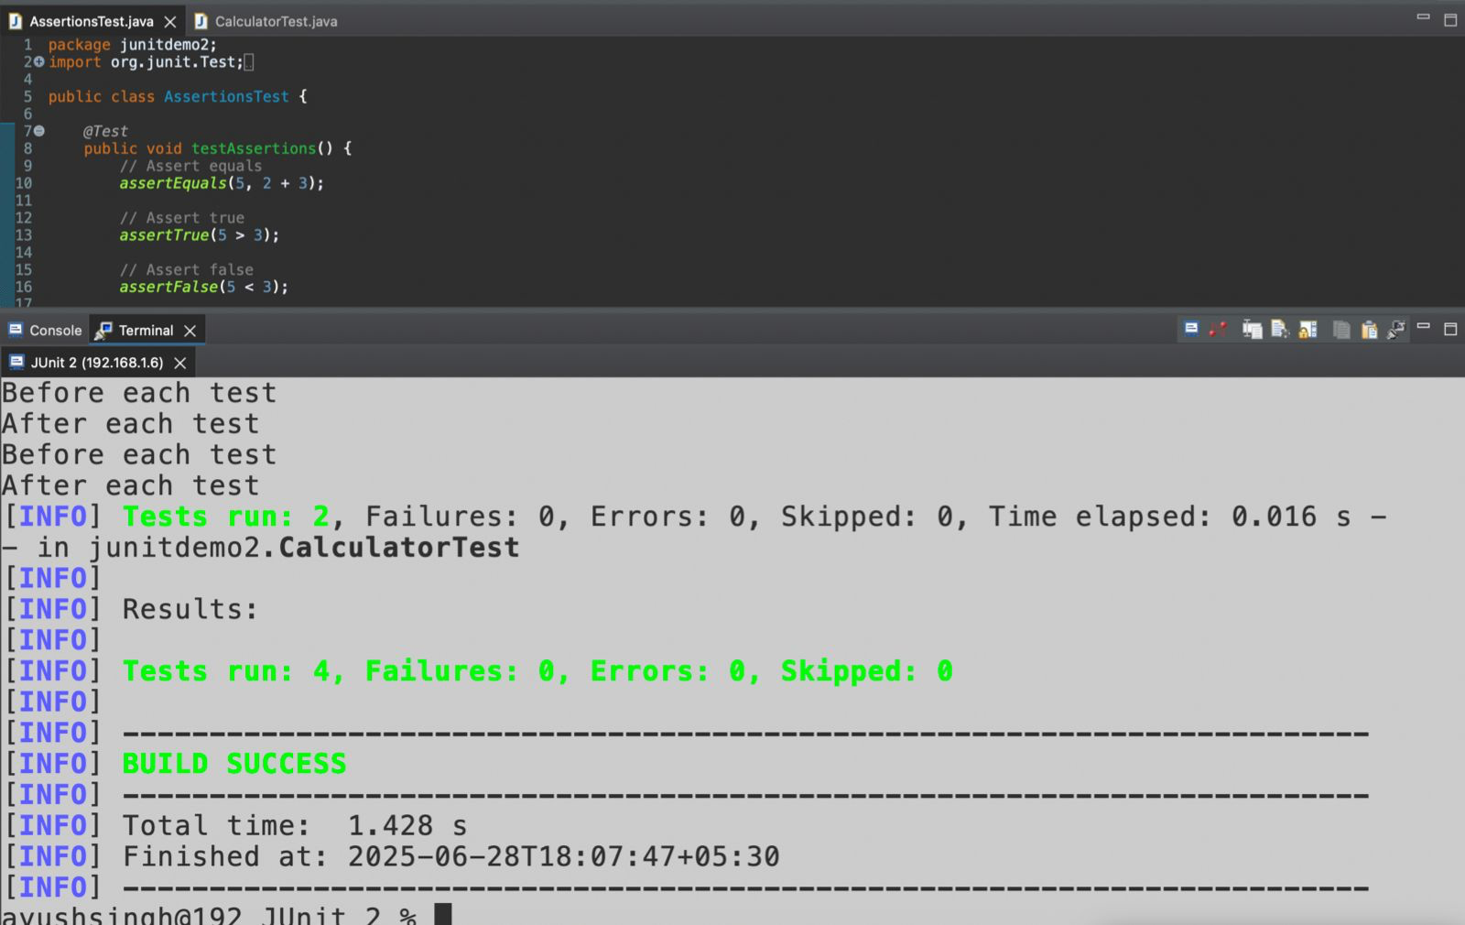

Exercise 4: Arrange-Act-Assert (AAA) Pattern, Test Fixtures, Setup and

Teardown Methods in JUnit

Scenario:

You need to organize your tests using the Arrange-Act-Assert (AAA) pattern and use setup

and teardown methods.

Steps:

1. Write tests using the AAA pattern.

2. Use @Before and @After annotations for setup and teardown methods.

Hands On:

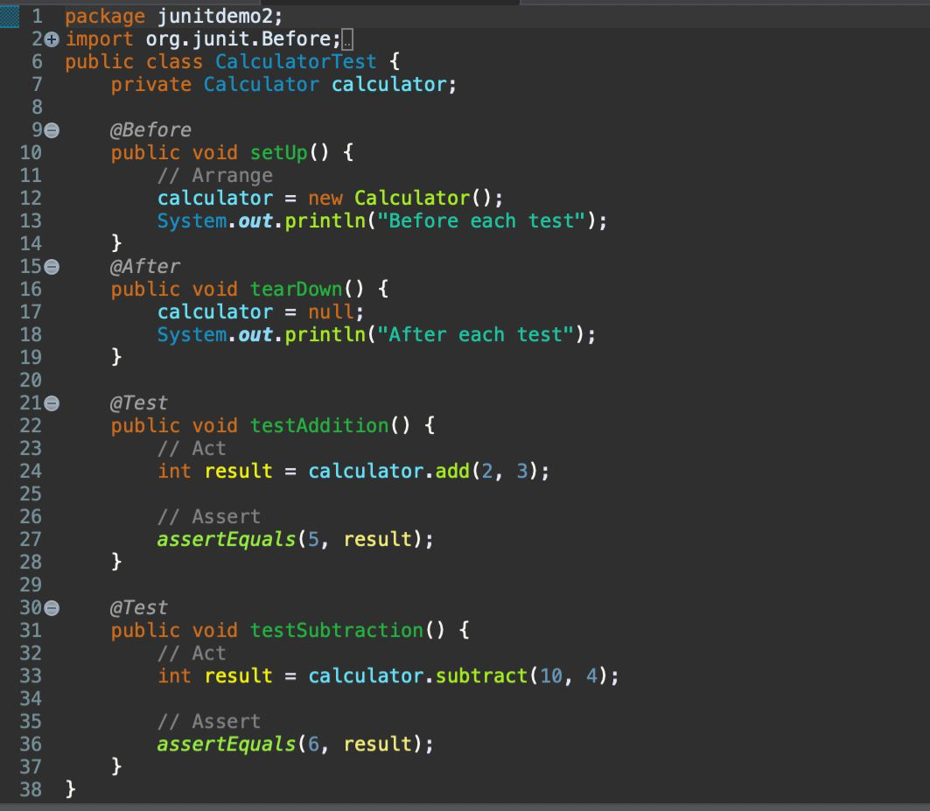

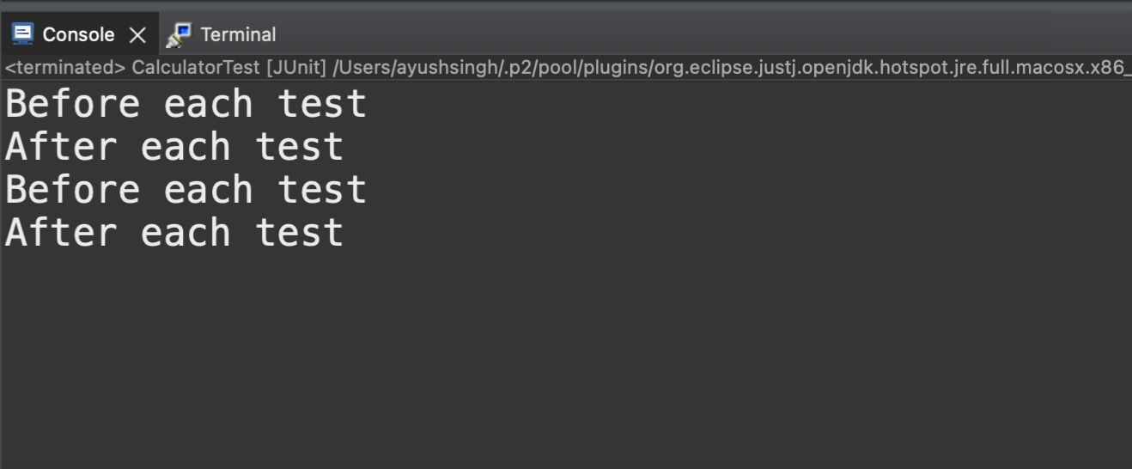Output: